Embedded System Testing

Project Work

Saurabh Jawahar Kakade

[sk2354@nau.edu](mailto:sk2354@nau.edu)

1. Dynamic Analysis:

* Proved the program with the possible and reasonable inputs in such a way to expose or uncover the subtle bugs in the code.
* Using fuzzer to pass the inputs to the executable makes the analysis as dynamic as possible. Providing inputs by use of fuzzers like afl,libfuzzer,default fuzzer helps the testers to improve the code coverage and also to enter the new paths in the code that cannot be reached when tested using manually written inputs.
* Command: ./testfile –fuzz –min_log_level 1 –timeout 2

Output:

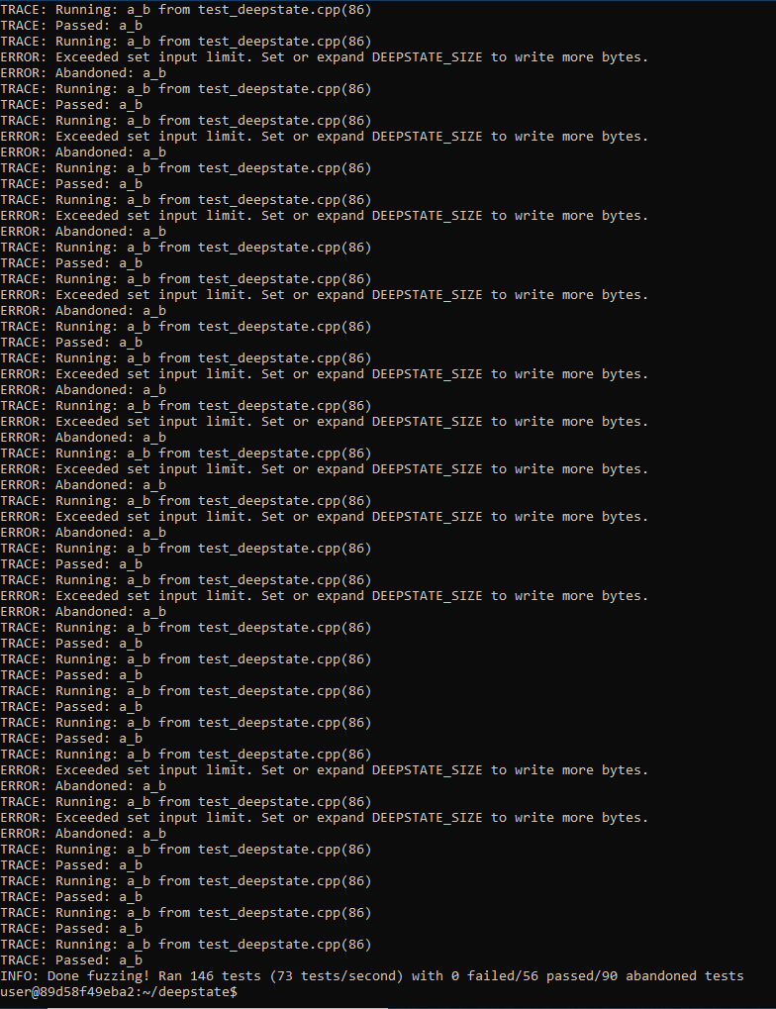

1. Static analysis:

First, the basic idea of static analysis is that it analyzes source code without running the code. This has advantages, but also serious disadvantages, when compared to dynamic analysis or testing.

Commands: cppcheck test_deepstate.cpp

Output:

